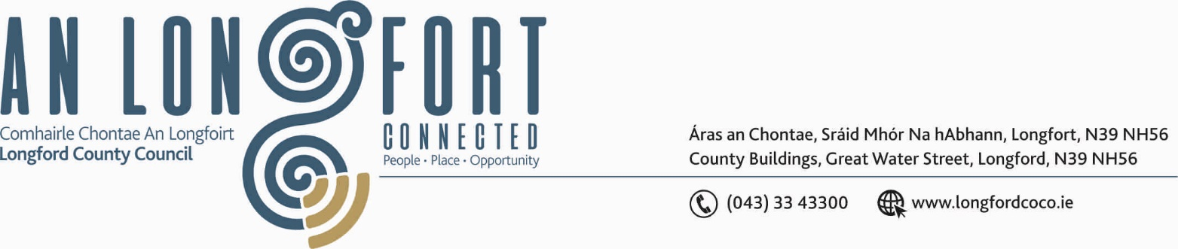

14u Meitheamh 2018.

Chuig: Gach Ball don Chomhairle.

A Chomhairleoir,

Iarrtar ort bheith i láthair ag Cruinniú Ginearálta Bliantúil Chomhairle Chontae Longfoirt a tionólfar i Seomra na Comhairle, Aras an Chontae, Longfoirt ar an Chéadaoin, 20u Meitheamh 2018 ag 4.00 p.m chun gnó a dhéanamh d’réir an Chláir thíos.
You are requested to attend the Annual Meeting of Longford County Council to be held in the Council Chamber, Aras an Chontae, Great Water Street, Longford, on Wednesday, 20th June 2018 at 4.00 p.m. to transact business, as set out on the Agenda hereunder.

Mise le meas,
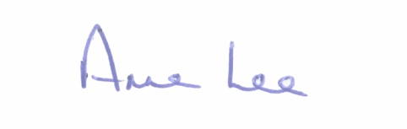

_______________
Anne Lee,
Meetings Administrator.

C L A R

Prayer before Meeting.

1. Election of Cathaoirleach.

2. Election of Leas Cathaoirleach.

3. Fix date and time of meetings.

